UNSTOPPABLE Ladies Power Player Rewards

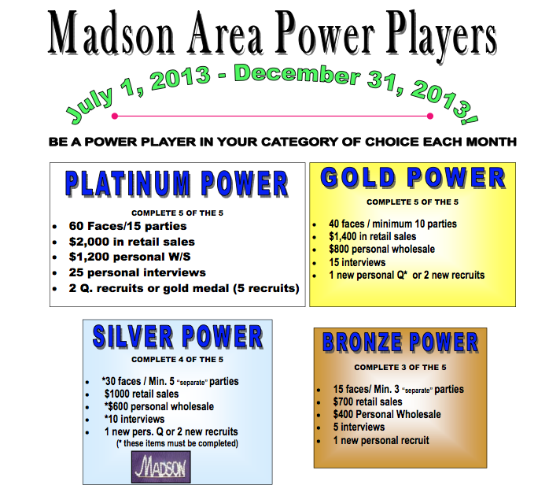

Bronze: You get a prize from Leah
Silver: $10 CASH from Leah
Gold: $20 CASH from Leah
PLATINUM: $50 CASH from Leah!!!!!!!

*Forms must be turned in to Leah by the 3rd of the Month!

