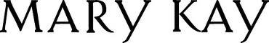
________________________________________________________________________________________________________

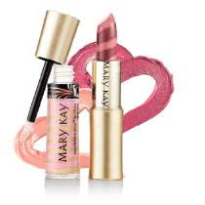
Beauty Boot Camp

Join us Every Saturday for an 8 week course.
Starting November 16, 2013 through December 21, 2013
40 East Sidney Ave. Mt. Vernon, NY 10550

Learn While You Earn!

Tips on how to teach skin care, beauty tricks, and
how to’s to maximize your parties and make them full circle.

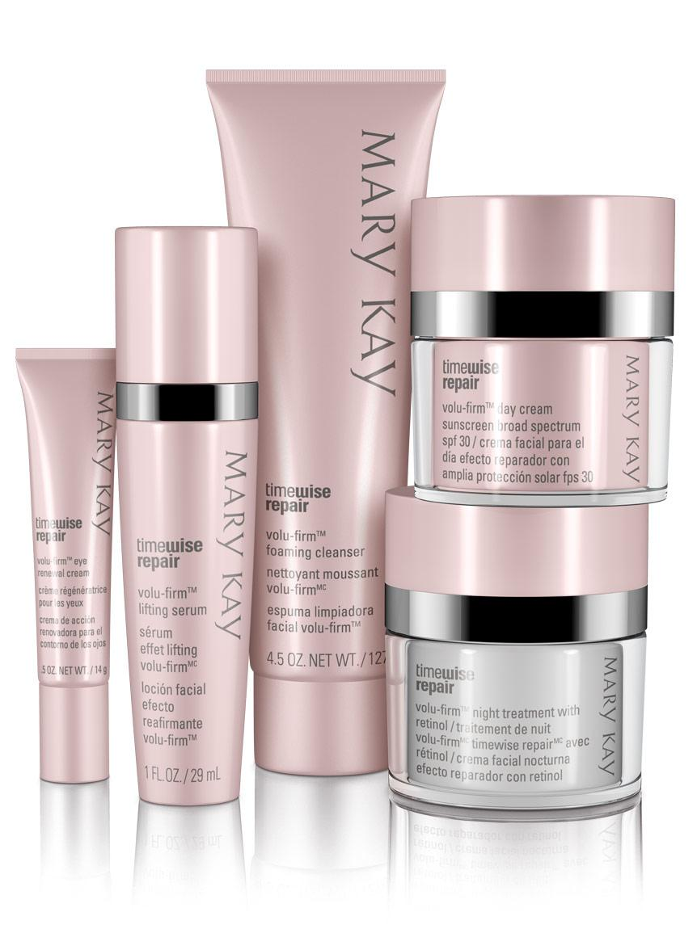

Our goal is to train all consultants that want to
become a master consultant and bring their
business and experiences to a whole new level.

