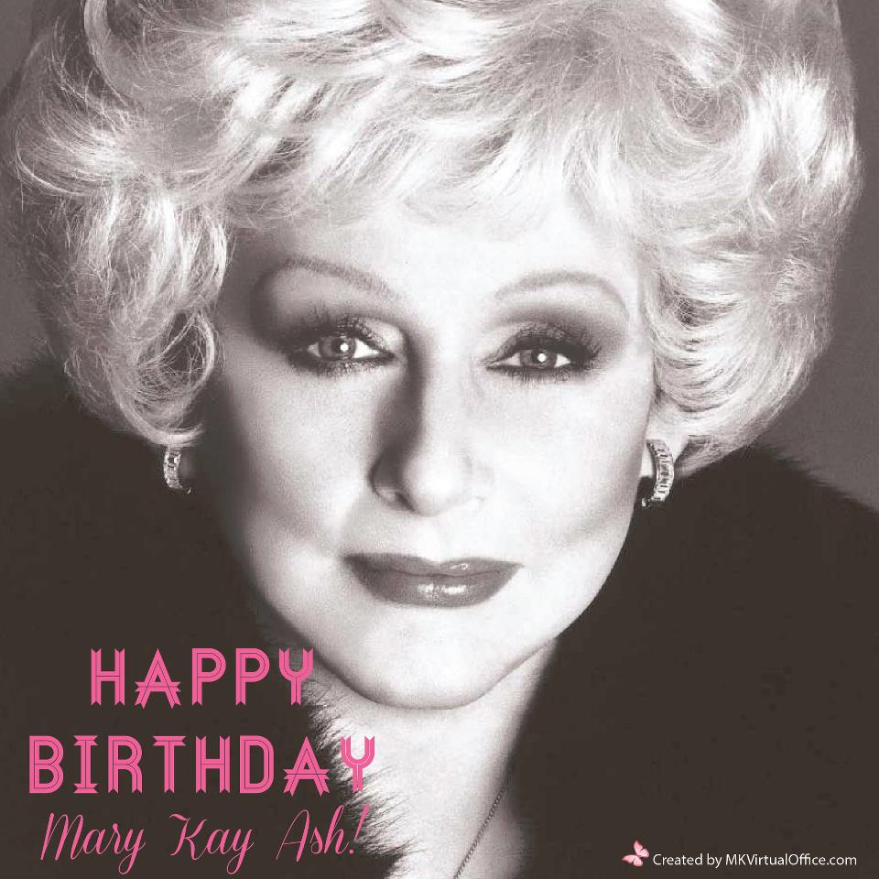Birthday Loyalty Scripts to honor Mary Kay Ash’s dream to Pass It On ~ May 2013

Hi ___________________It’s Daria’s assistant Rose with Mary Kay. I am calling today to say Thank you for using Mary Kay products in the past. I am excited to share that Mary Kay has entrusted Daria with the growth of this area. We are calling you today invite you to partner with us because She is looking for a woman just like you, a woman who love the product, a woman of integrity, women who are loyal, women who love great products, women who are looking for something more, more money, more time, more opportunity, women who are looking to belong to a group of fabulous like minded people,
You see ( customer’s name) Mary Kay does not advertise, Mary Kay’s huge growth comes from loyal customers like yourself and that is exactly why we would love to partner with you to honor Mary Kay’s dream to pass it on. It is our 50th Anniversary year and there has never been a better time!!!
Now (customers name) this may or may not be for you and that is ok either way but who do you know that might be that woman? (Be Quiet)
For every woman you refer that becomes a qualified Mary Kay beauty consultant Daria will credit your account $50 for you to enjoy in fabulous Mary Kay products.
next*if she does not know anyone or in addition to the referrals she gives you
Daria is also offering the ‘Gift of Beauty’ to each of her loyal customers to present to their friends and family. (her name) Who do you know that is celebrating a special occasion? (like a birthday? An anniversary? A wedding? Sweet sixteen? Graduating? Retiring?...ect…)
She will be delivering a beautiful card on your behalf ( use *Send Out Cards or deliver in person at her place of employment) which will include A Gift of Beauty from you at absolutely no cost to you. The gift is totally complementary and your friends are under no obligation to purchase anything…Should they decide they would like to shop…. then once again you will receive a credit to your Mary Kay account of 10% of their purchases. We like to call this the Gift that Gives

They will receive a wonderful pampering session complete with a brand new “on trend Look”, a hand treatment and a microderm abrasion experience ~
(Only if you have great rapport) lol if your like me I love to give presents to everyone, including me Hahah when I Christmas shop it is like here is one for you and you and one for me
(_____________) Thank you so much for being the kind of woman who always thinks of others and for partnering with us to honor Mary Kay’s dream. It is the highest compliment you can ever pay us as Daria really values your business but more importantly your friendship.

With Your Beauty in Mind,
Daria Rocco 5/12/13
QTOFFICE ( referral credit use drocco )
Send Out Cards ( use Holly Condina to sign up )

