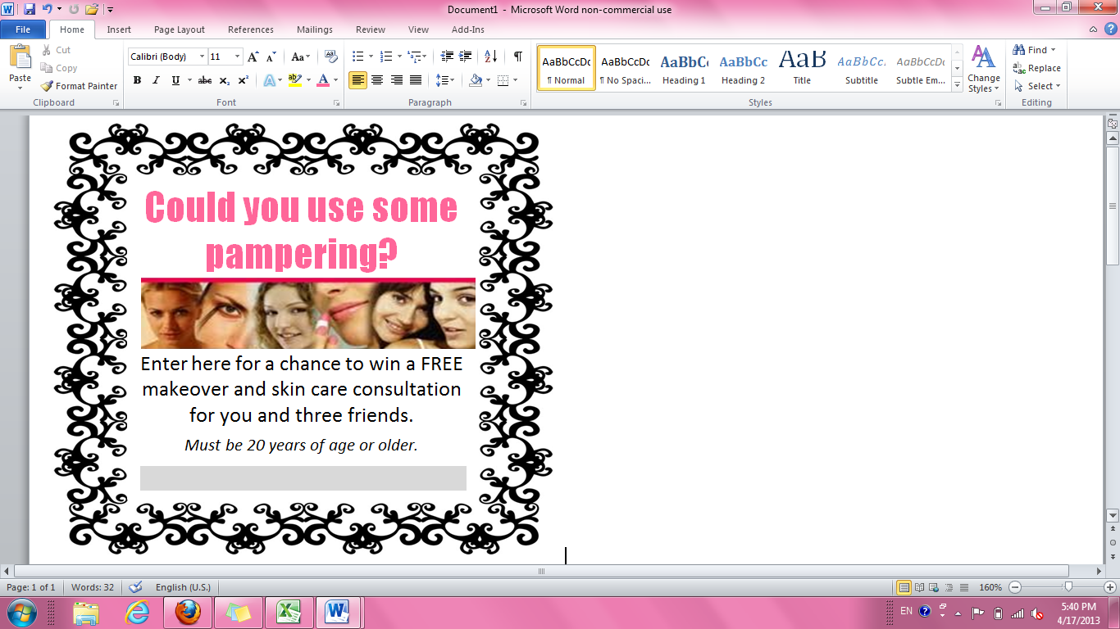

Could you use some pampering?



Enter here for a chance to win a FREE makeover and skin care consultation for you and three friends.

*Must be 20 years of age or older.*