Applying For Credit
Making the right choice for you!
by Sr. Director, Michele Tufenkjian
Please scoll down for more information.
Click on the Card for more information and to apply.
Applying for credit cards is sometimes not a simple process! If you wish to apply for a card, you first must know what your credit is like. For instance, if you are over-extended heavily or you have a history of constant late payments, you probably will not be approved for a regular card. You may need to apply for a First Premier, Capital One or Providian as they have different cards for people that have less than great credit scores. Keep in mind if your credit is not good, and you are accepted for a card, you may have to pay a higher interest rate because you are considered a "High Risk". Don't let this discourage you. Go ahead and get some credit established in your name even if it is a higher rate.

After 1 year of excellent payment history, you are often able to re-negotiate a lower rate. The better your credit gets, the more you can apply for a lower credit. All credit is "score driven". A score of 700 - 720 or above is considered to be excellent! From 650-700 is pretty good but if its 650, it is usually starting to signal that you may be over-extended or close to your maximum. Anything lower than 650, you will have to find a card that is especially for those wishing to re-establish poor credit. Cross Country Bank and First Premier are excellent cards for people that have poor credit, although First Premier also has cards for people with excellent credit. They are perhaps the best 2 companies that help people with poor credit. You will have to pay a one time processing fee, and possibly another fee, but well worth it to establish or re-establish your credit. Don't get hung up on the numbers if your credit is not good.

Below are several cards that you can apply for. Of course, your bank is sometimes even better as you already have a relationship established with them. Some people may need a co-signer (or co-applicant) to help them out to get started. If you have someone who believes enough in you to help you get started, - it's ok. Its a way to get you going. Anything is better than sitting doing nothing to change your circumstances! When National Sales Director Pamela Shaw started her Mary Kay Business, she was $16,000.00 in debt. She was turned down by bank after bank, after bank - but she didn't give up. She persisted and found a bank that would loan her the money to get started - at a rate of 28%! She didn't let herself get hung up on the rate because she knew that this business could get her out of debt - and it did! She is now a National Sales Director and 8 years in a row in the Million Dollar Achievement Circle! Was it worth it for her? You bet! That certainly doesn't mean you would pay that today. There are so many different rates available today that weren't available 10 years ago. Shop around but keep in mind that if you have poor credit, you will be paying a higher interest rate.
So often I hear of so many women tearing up their credit cards due to a divorce, etc., which leaves them now with no credit! This is the worse thing you can do because no credit is worse than bad credit. If you have no credit - it is very hard to get something established & you will be turned down constantly because "you have no credit history". Its very frustrating being turned down over and over because of "lack of credit" and you will find yourself asking "how am I supposed to get credit when no one is willing to give me a start"? It is best to keep just 1 credit card if you find yourself in a bad situation. At least you are keeping some credit in your name. Not having a Checking Account is a RED flag to everyone that you are a very high risk and a poor money manager which means no one will extend credit to you. Consider learning how to manage money better, and develop better skills by taking a course in basic accounting or money management to help you understand the importance of mastering this crucial skill. If you have never "balanced" a checkbook - now is the time to learn! Poor money management is the number #1 reason why Consultants fail! Don't let yourself get caught in this situation.
You can apply at the following:
24 Hour VISA... US Bank Visa 402-484-3784 only in the state of NE.
National city cards- www.pnc.com
Chase card- www.chase.com
Citi Advantage Air Miles Mastercard (www.citibank.com)
United Milage Plus Air Miles Visa (www.firstusa.com)
Platinum Miles One Visa (www.apply2.capitolone.com)
***CLICK ON ONE OF THE CREDIT CARDS BELOW TO APPLY***
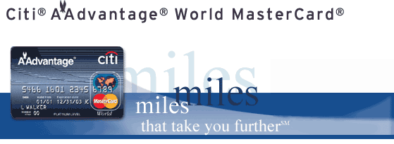
Citi Advantage card - Airlines miles card. Will need good credit to apply
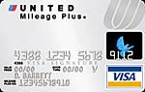
United Airlines card - Will need good credit
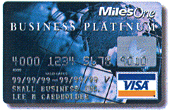
Capital One Visa - another good Airlines mileage card. Good for people that have fair to very good credit or if you need to establish alittle more. Instant approval. Has different cards depending on your credit situation.

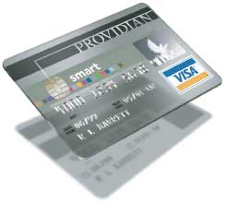
Provdian is a good card and one of the largest card providers in the US. Providian is also a good source for people wanting to establish credit. Credit cards and interest rates varies depending on your credit score. Remember if you are trying to re-establish credit, or to build more credit, you may have a higher interest rate because of your poor credit score. It is better to try to re-establish your credit, show a record of timely payments, then after 1 year, you may be able to re-negotiate a better rate or even switch to another card. But you must first establish a good payment record. Having no credit is worse than having poor credit!
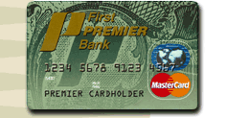
First Premiere Cards
This company is great if you have bad credit including bankruptcy. No instant approval. Credit limit is usually between $300 and $500 - depending on your score. Annual fee and a higher interest rate apply but well worth it if you need to re-establish bad credit or no credit. After you have had the card for 2 years - you should be able to apply for one with a better interest rate and no annual fee. You can transfer the balance from this card to your new one.

Also - you may apply for a Cross Country Bank Credit Card. It is the same as First Premiere and Centennial. Go to their website (www.crosscountrybank.com) for more information
* Check financial companies like ITT, Trans South, Commercial Credit, or Household Finance (HFC); Start looking in the phone book in your local area.
* Borrow the cash value of life insurance policies.
* Have a relative put a certificate of deposit in a bank and list you as the co-owner. the bank then has to loan the new consultant up to that amount.

