Skin Care Class Supplies
Highly recommended to add to the products in the Starter Kit:
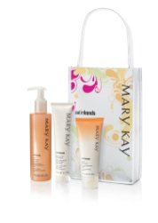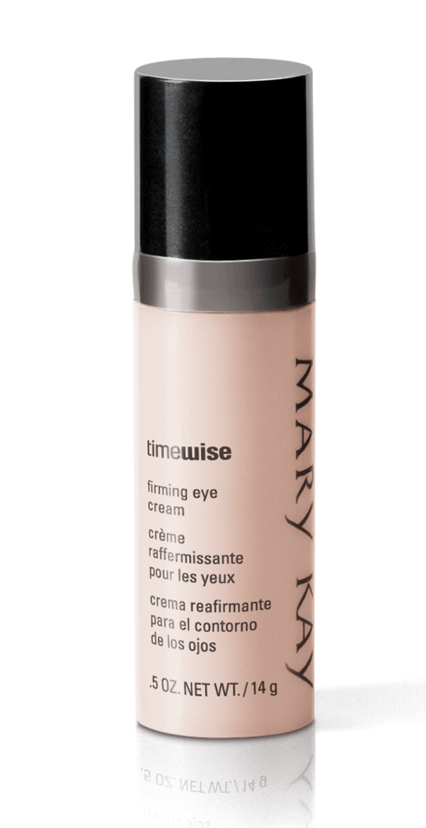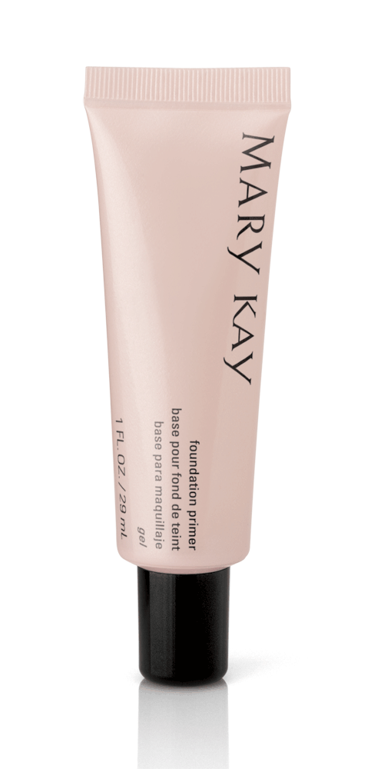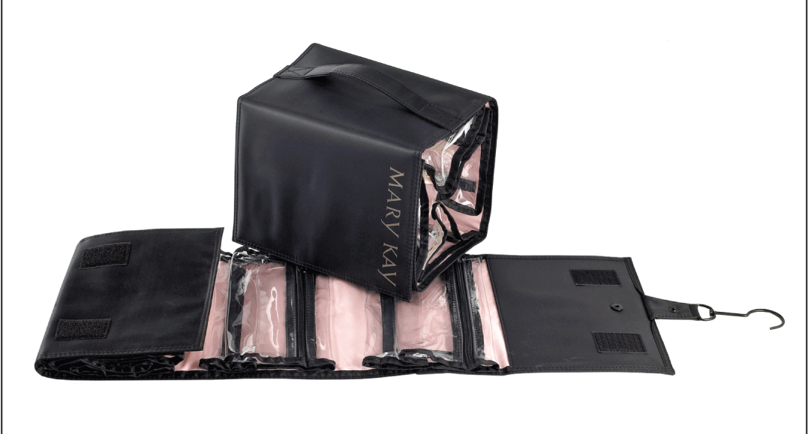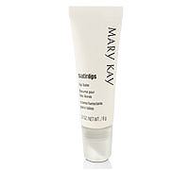
Full size Satin Hands, Satin Lips, Firming Eye Cream, Foundation Primer, & Roll Up Bag
You can add later, order them and use the unused products just to show:
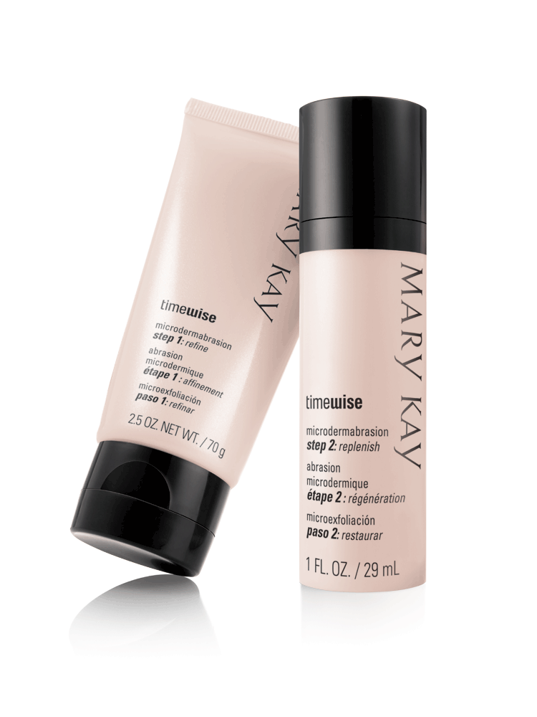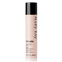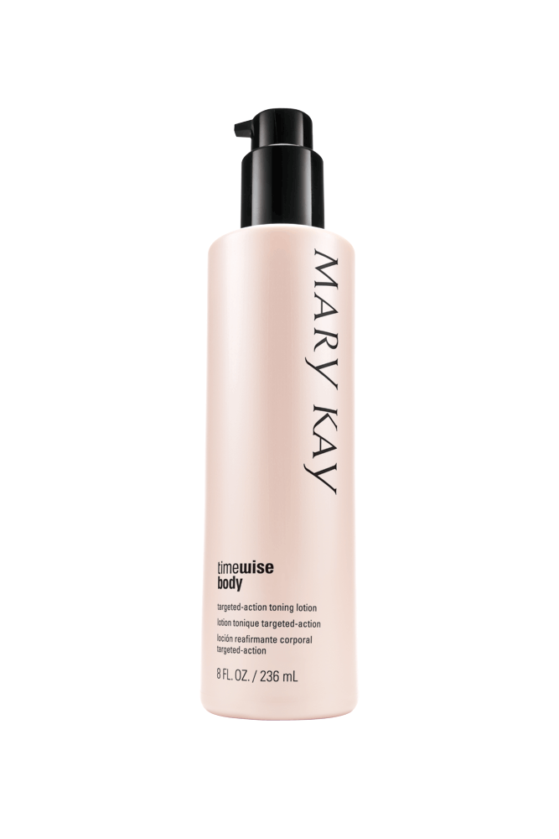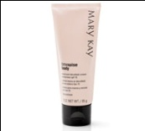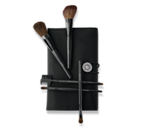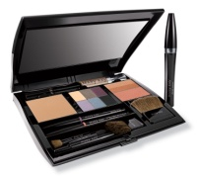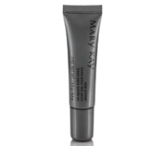
Microdermabrasion, Serum C+, Toning Lotion, Hand and Décolleté Cream, Brush Set, Filled Compact, Eye Primer
You will want to eventually get the foundations that you do not have in your kit as well
When you come to events and facials you will want to have:
Flip Chart or script, Before and After Pictures, Closing Sheets, Customer Profile Cards, Sales Receipts, Beauty Books, Mirror and Tray, your product in your kit and others you are demoing, facial cloths, eye applicators, mascara brushes, LOOK card, cotton ball, pen, Look Books, headband if desired.

