

If you have a friend who lives too far away from you for you to give her a facial, you could mail her a Facial in a Bag so that she can give herself a facial at home. It can also be used for friends or co-workers who just don't think they have time to sit down with you for a facial.

It should NEVER replace the single or double facial or the skin care class! You will ALWAYS build a stronger business if you personally give a facial to your customers. But this can work for you in those special times when you can't personally get with your client. And it opens up the entire country for your business!

The key to success with this method is follow-up. If you don't follow-up, you have wasted your time and money. And once she has sampled the product at home, she may find the time to schedule a personal makeover with you.

These pictures will give you an idea of how I put the Facial in a Bag together, although they are not our newest samplers and Beauty Book. Just use the new ones and drop them into the bag. I no longer tape them into the beauty book.

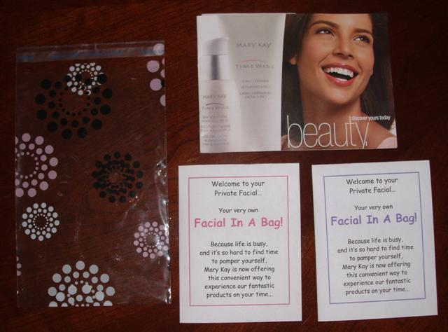

Here's what you need:
5 x 8 self-sealing bags from My Girlfriend's House (same bag I use for goodie bags) or medium-sized cello bags from a party store or Hobby Lobby. If you use the cello bag, just tie it with ribbon (The new Beauty Book is larger than the one you see here. My Girlfriend's House does have bags that will fit the new Beauty Book--it would be their 6.25 x 9.5 bag.)
Foil Sampler Packets from Section 2
Cleanser and Moisturizer Samplers (part # 862900 and # 862700) --a 2-part sampler (don't separate the Cleanser from the Moisturizer)
Day and Night Solution Samplers (part # 002338) --a 2-part sampler (don't separate the Day from the Night)
Microdermabrasion Set Samplers (part # 000177) --a 2-part sampler (don't separate the Step 1 from the Step 2)
Firming Eye Cream (part # 003215)
A Beauty Book
With the new beauty book and the new black and white samplers, I no longer tape my samples onto page 18, like I used to. I now just drop the samples into the bag along with all the other things, and no longer cover up the picture of the miracle set on page 18.
Facial in a Bag Instruction Sheet Booklet
The purple one is for Combination/Oily TimeWise Cleanser and Moisturizer samplers.
The pink one is for Normal/Dry TimeWise Cleanser and Moisturizer samplers.
Depending upon the samplers that were taped to the Beauty Book, whether the purple swoop for C/O or the pink swoop for N/D, include the correct instruction booklet.
The contact box on the back of the instruction sheet booklet can be edited with your own personal information.
A business card

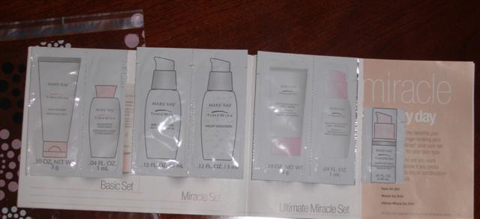
Double stick tape the samplers to pages 18 and 19. (I no longer tape these in since we got new beauty books and new black and white samplers.)

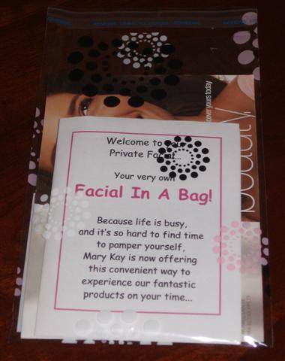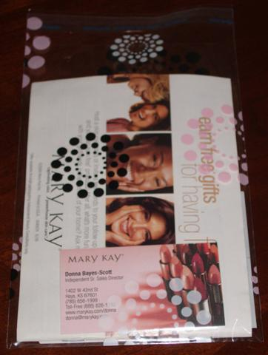
Place the loaded Beauty Book inside the cello bag with the appropriate instruction sheet on top and your business card in the back.

Facial in a Bag Instruction Sheet tips
You'll notice that we gave the instructions for the facial according to the way I do a skin care class.
On one side of the face, the "pampered side" we have all of the products, including both Day and Night Solutions.
On the other side, they will only have cleanser and moisturizer.
I'm such a believer in the 1/2 face approach to a facial. When a customer tries both the day AND night on one side, they will feel a dramatic difference between the two sides.
I don't just put the Night Solution on the back of a hand, because this is the product that makes such a difference in the way the skin feels.
You always put the NIGHT Solution on first, then the Day Solution right on top.
Try it yourself and see!
You'll notice that there are no foundation samples or color samples included. It would be your choice to add more. But most ladies would try it at night after work, and they would be ready for bed without washing the products off.
You are focusing on the skin care system--the Ultimate Miracle Set--which should be the foundation of our business. You can share with her that the set also includes foundation.

