

**Men’s Night & Networking**

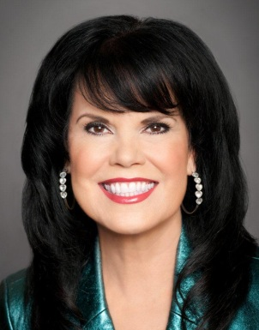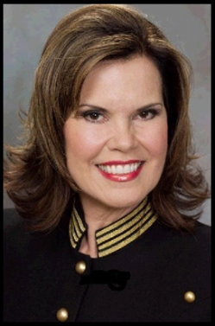

Monday, May 19, 2014 at 7pm

Radisson Hotel

4545 MacArthur Blvd.

Newport Beach

**Featuring:**

**NSD Cristi Ann Millard**

As a Sales Director working part time (25 hrs per week), Cristi Ann was able to drive the coveted Pink Cadillac and replace the income she made owning her own nursing company. As a Senior Sales Director, (working 40 hrs per week) she was making over $100,000 per year. Her highest monthly earnings for one month was over $20,000!

Cristi Ann debuted as a National Sales Director in 2005. She has earned over $1 Million dollars in commissions in her Mary Kay businesses.

Bring the man in your life…your husband, boyfriend, significant other!

This night is for HIM! We want to get the men’s opinions, so let your man know he’ll be heard.

This will be fun and informational.

**\*\*We Will Be doing Women’s Makeovers Too\*\***

**For additional information and to RSVP, please call:**

949.716.9642

or email: cristiann@cox.net

**Bring on the MEN!**