New Consultant Prizes - WIN THEM ALL!! You can DO IT!!

8 parties booked for your Perfect/Power Start - Your MK Business card holder

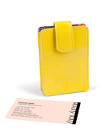
8 parties held- 30 faces done for your Power start in one 30 day period – MK sunglasses

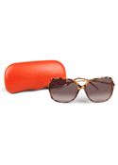

3 Practice interviews with your director – your Pearl Earrings
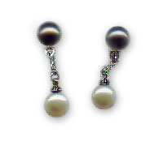

3 More Practice Interviews with your director – your Pearl bracklet

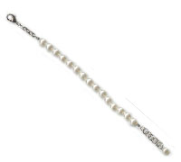

First new Qualified recruit – your Pearl necklace
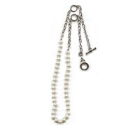

Start business with Products on Hand with $1800 min order – get a Rolling Tote from your director and your FABULOUS Glitz calculator
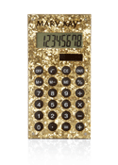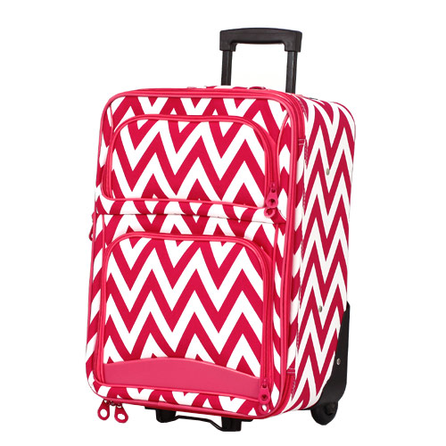

Start with a $600-1700 in products – get the Fabulous MK @ play color roll up bag

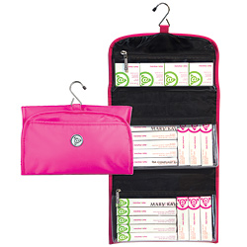

Held your Business Debut on the original date with your director, min 6 people there for facials or 15 people min for an Open house – get your MK money bag!
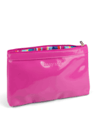

Do your Education calls/watch and do the education on the MK Intouch website – get your official MK pen to fill your calendar for future bookings.
