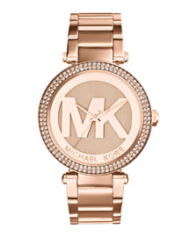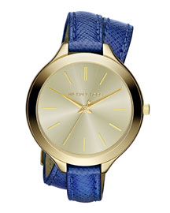 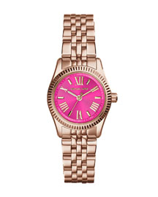

Who wants a Michael Kors WATCH?????   
**YOU CAN GET ONE THIS MONTH!! We are reaching for HUGE GOALS so I am giving away HUGE THINGS!! I will give away 4 watches when we reach CADILLAC STATUS THIS MONTH!!!**

**You get enter to win a MK Watch the following ways:**

**\* 1 entry when you place a $400 order and additional entries for each $200 after**

**\* 1 entry for every person you recruit (doesn’t have to be active)**

**\* 5 entries for a recruit becoming qualified with $600 or more**!

**\*\*\*Person with most recruits will get a massage as well when we reach goal! \*\*\***

