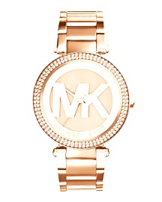

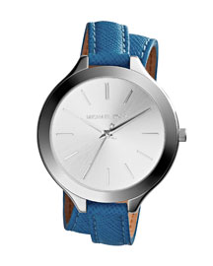 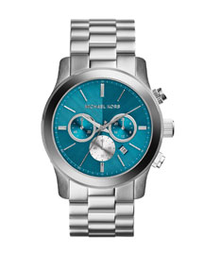

**Who wants a Michael Kors WATCH?????   
Get your chance at one of these AMAZING Watches by doing one or all of the following:**

**\* 1 ENTRY WHEN YOU HOLD A FACIAL APPT WITH YOUR CONSULTANT**

**\* 1 ENTRY FOR EACH GUEST YOU BRING TO YOUR APPT, PLUS EACH GUEST GETS ENTRY FOR THEMSELVES TO WIN!**

**\* 1 ENTRY WHEN YOU DO A PRACTICE INTERVIEW OR GO TO UNIT WEBSITE AT CAROLINEBEASONUNIT.COM, CLICK CAREER OPPORTUNITY, WATCH A FEW VIDEOS AND FILL OUT THE QUESTIONAIRE.**

**\* 10 ENTRIES FOR STARTING YOUR OWN BUSINESS AND GETTING YOUR KIT DAY OF YOUR APPT.**



